From: https://davidstockmanscontracorner.com/the-curse-of-keynesian-central-banking-why-ford-was-sent-to-the-junk-yard-part-4/

The Curse Of Keynesian Central Banking: Why Ford Was Sent To The Junk Yard, Part 4
By David Stockman. Posted On Tuesday, September 10th, 2019
If collective headstands in the Eccles Building would be just as efficacious as QE and ZIRP when it comes to main street growth, jobs, incomes and inflation, the same cannot be said for the Fed's impact on Wall Street.
When it comes to the latter, the Fed's machinations are more than efficacious. In fact, they have unleashed a veritable boom in speculation and momentum chasing---a tsunami that sweeps up all in its path including the C-suites of corporate America which have become utterly addicted to cheap debt and financial engineering.
So doing, the C-suites have massively rechanneled corporate cash flows and balance sheet capacities into
- stock buybacks,
- vastly over-priced and uneconomic M&A deals and
- other forms of leveraged de-capitalization.
At length, the economic resources channeled back through Wall Street end-up on the inflated balance sheets of the 1%, even as productive investment on main street goes wanting.
Today's poster-boy for the evils of central bank fueled financial engineering is the venerable Ford Motor Co., which was sent to the financial junk yard last night when Moody's pulled its investment grade rating.
Well it might have. As shown below Ford has spend the past six years of the present so-called recovery trashing its balance sheet.
Thus, in December 2013 it had $114.7 billion total debt, which represented 7.5X its LTM EBITDA of $15.2 billion.
Needless to say, no sane company in the fiercely competitive and vastly over-capacitated global auto business would have even close to that kind of excessive leverage----and especially one that escaped by only a hair the ignominy of bankruptcy experienced by GM and Chrysler during the financial crisis. At that point in the cycle (2013), for example, Toyota had a debt/EBITDA ratio of only 4.3X.
But what happened next gives the old saw about letting a good crisis go to waste a new definition. To wit, by Q2 2019, Ford's debt had soared to $156.0 billion, while its EBITDA had shrunk to just $4.0 billion.
You really can't make this stuff up. When Ford needed to cleanse itself of debt in preparation for the next global recession and automotive industry over-capacity and cash flow collapse, it did the opposite---pushing its leverage ratio from 7.5X to an incredible 39.0X!
Of course, financial engineering did not help. Even as Ford's global sales have stagnated at $150-$160 billion during the last six years, and net income has plummeted from $12 billion in 2013 to $4.0 billion during the LTM period ending in June, the company's leadership saw fit to distribute nearly $19 billion in dividends and stock buybacks.
These unearned distributions occurred, of course, even as Ford's China business was heading south and the global auto cycle was peaking, and is now sharply deteriorating.
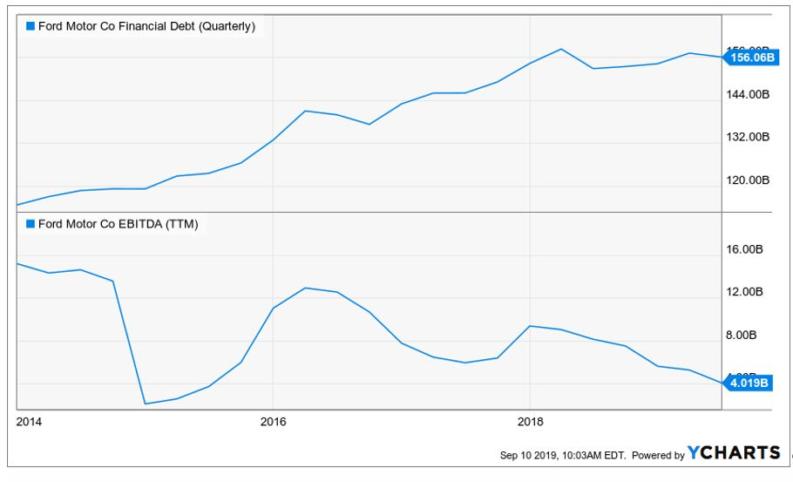
F Financial Debt (Quarterly) data by YCharts
Nevertheless, the corporate bond market remained oblivious. Prior to last night's downgrade, Ford's 5.113% notes of 2029 were trading at a yield of just 3.16%. That means they were being priced at a considerable premium to par, but for one reason alone.
Namely, with the central banks having driven fully 30% or $17 trillion of the world's $50 trillion in sovereign and investment grade bonds to into subzero land, portfolio managers have become literally crazed in their desperate quest for yield.
Accordingly, they ended up pricing the debt of an auto company steadily stumbling toward the bankruptcy courts at nearly 105% of par. And that's just plain whacky.

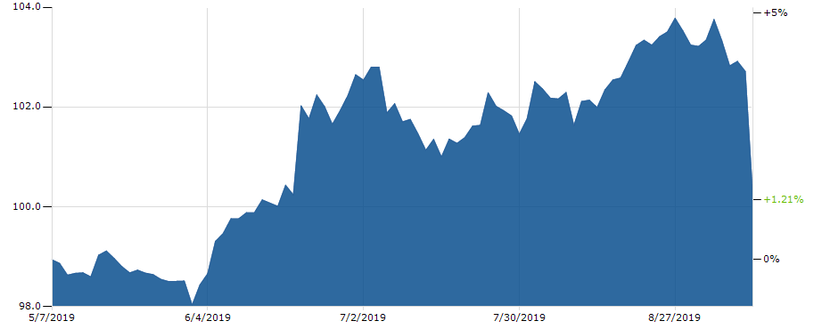
More importantly, all of this cheap debt did not go into CapEx----the ostensible reason for the Fed's massive and chronic interest rate repression. In fact, since the late 1990s Ford's CapEx to sales ratio have declined by 40%.
Stated differently, Ford is a classic case of a storied company that needed to equitize its balance sheet and drastically step-up its investment rate in order to remain viable in the fiercely competitive global auto markets.
But that didn't happen because Keynesian central banking and the systematic falsification of debt prices has stood the equity markets on their head: They were originally---and on the free market would have remained---venues to raise capital and issue shares, not casino halls were good equity money is swapped for chips to be bet on red.
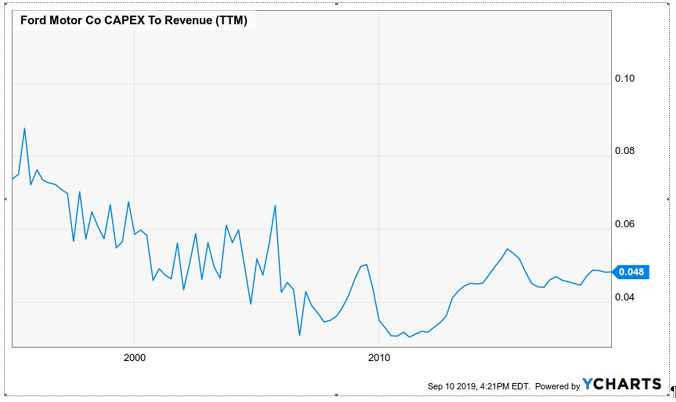
Nor is Ford some kind of outlier when it comes to under-investment in productive assets and de-equitization of balance sheets. As shown in the chart below, real fixed business investment---after covering inflation and depreciation---finally climbed just a tad above the year 2000 level last year for the first time this century.
Accordingly, the 18-year "growth" rate clocked in at a mere 0.78% per annum. How a capitalist economy is supposed to grow robustly when its net real investment rate is stuck in creeper gear our genius central bankers do not say.
And to some substantial degree that's because they don't even notice or credit the crucial role of net investment in market based economies .
What we mean is that the PhDs running the US and global financial system from their central banking perches are obsessed with gross flows, but are oblivious to balance sheets. That's because the latter don't even factor into their DSGE (dynamic, stochastic general equilibrium) models.
Needless to say, however, when gross investment only replaces in part or whole the balance sheet assets consumed in current year production (i.e. depreciation and amortization) that's not in the slightest a healthy condition; it's the accounting evidence of stagnation or worse.
So it is not surprising that Keynesian central bankers have missed the boat entirely when it comes to the vanishing rate of growth investment in the business economy. While they occasionally remark upon the current year flow of nominal gross fixed investment (modest as it has been), no Fed head as ever made even a glancing reference to the 18-year stagnation of real net business investment shown below.
In a word, the miniscule 0.78% rate of real net investment growth since the year 2000 in is far, far more important than the noise-ridden U-3 unemployment rate, the labor force participation rate, the monthly jobs print or the 16 other labor market metrics that Janet Yellen used to have on her desk, and which today's labor market focussed central bankers still dwell upon.
Of course, there is surely a subconscious reason why the chart below will never appear in a Fed briefing book. To wit, it proves that when it comes to the growth and health of the main street economy, the occupants of the Eccles Building might as well be doing headstands.
Notwithstanding massive balance sheet expansion---from $500 billion at the turn of the century to $4.5 trillion at the recent peak----and endless props and puts beneath the stock market, their ministrations have had no impact at all on capital formation----the single most important driver of economic growth.
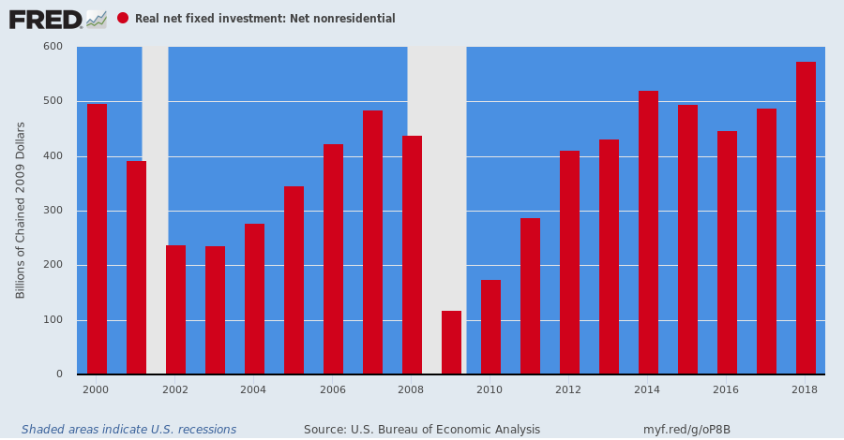
Nevertheless, the stimulus beat goes on. Keynesian central bankers are blowing ever greater financial bubbles while steadily draining the financial lifeblood from the main street economy, but they admit no hint of recognizing their destructive regime whatsoever.
At the present time in Europe there is virtually no investment grade debt left that carries a positive current yield. So desperate yield seeking capital is being lured into drastically over-valued junk bonds and ever longer duration instruments, such as the absurd Austrian 100-year sovereign bond which was recently trading at 210% of par.
Still, in his last hurrah Madman Mario Draghi is fixing to go full NIRP retard, driving the ECB's already absurd -0.40% deposit rate even deeper into subzero land at this week's meeting.
Fortunately, European bank bosses seem to be finally realizing that the ECB has placed their heads on a financial guillotine by making the fundamental business of commercial banking unprofitable!
The ECB's imposition of negative interest rates have created an "absurd situation" in which banks don't want to hold deposits, rages UBS CEO Sergio Ermotti, arguing that this policy is hurting social systems and savings rates.
That's right. Or as Bloomberg reports, Deutsche Bank CEO Christian Sewing warned that more monetary easing by the ECB will have “grave side effects” for a region that has already lived with negative interest rates for half a decade.
In the long run, negative rates ruin the financial system.....Another cut “may make refinancing cheaper for states, but has grave side effects.....all it would achieve is to further divide society by lifting asset prices while punishing Europe’s savers who are already paying 160 billion euros ($176 billion) a year because of negative interest rates.
To be sure, Europe's "savers" were euthanized long ago. But perhaps the calamitous impact of squeezing the veritable lifeblood out of capitalism is being finally recognized and for an obvious reason.
To wit, the European banking industry is literally dying on the vine and the index of European bank stocks tells you all you need to know: It's now all the way back to levels first crossed in 1988.
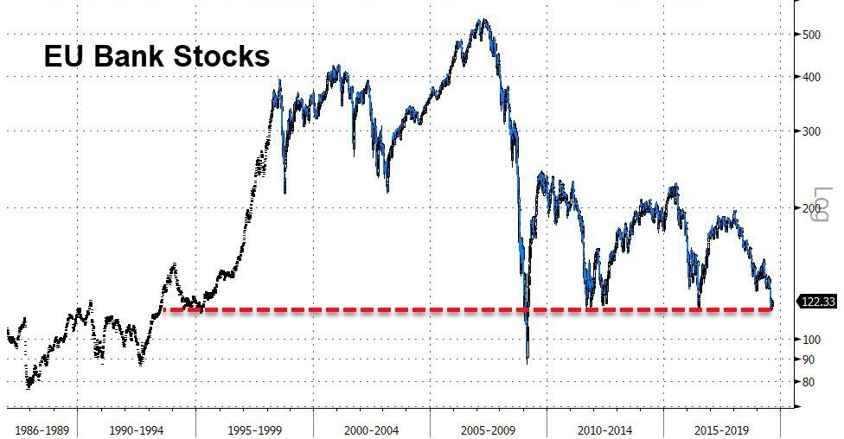
So Ford Motor Co. is indeed a poster boy. In the name of "stimulus", our cursed Keynesian central bankers are actually strip-mining what is left of the main street economy.

